Name

Mathematics Stage 5 Core
Expanding Expressions

Book 1 |  | Version: 261002  Feedback:  https://MrDingMaths.com
Contents
Syllabus Content 2
Learning Intention 3

Syllabus Content
MA5-ALG-C-01 simplifies algebraic fractions with numerical denominators and expands algebraic expressions
Apply the distributive law to the expansion of algebraic expressions, and collect like terms where appropriate
- Expand algebraic expressions, including those with negative coefficients
- Expand and simplify algebraic expressions by removing grouping symbols and collecting like terms where appropriate
- Expand binomial products algebraically using the distributive law or consider areas of rectangles as a possible method of expansion

Expanding Brackets with Negative Coefficients

- Review
- Expand brackets
- $7(l+4)$ | - $4(2x-6)$ | - $5(3e+8)$
- $9(x-9)$ | - $10(6g-7)$ | - $7(8x-2)$
- $6i(t - v)$ | - $7y(4y+7g)$ | - $14k(k-3)$

- Expanding Brackets
To expand brackets, we use the distributive law:

$$a\left(b+c\right)=ab+ac$$

- Example Expand brackets using the distributive law
Expand:
$-x(2y-z)$  $=-2xy+xz$ | To expand a bracket, multiply e………… term inside the brackets by the term o……………

- Guided Practice
Expand:
- $-3(m+3)$  $-3m-9$ | - $-(y+4)$  $$-y-4$$ | - $-5(2m+7)$  $-10m-35$
- $-x(8-3m)$  $$-8x+3xm$$ | - $-y(y-9)$  $$-y^{2}+9y$$ | - $-4t(t-8)$  $-4t^{2}+32t$

- Key Ideas
- The distributive law says to expand brackets by …………………… the term on the outside by the terms on this inside of the brackets.
- In the expression $-x\left(a+b\right),$ we multiply each term inside the brackets by ……………

Foundation
- Expand these expressions.
- $3\left(x+4\right)$  $3x+12$ | - $-6\left(2-x\right)$  $$-12+6x$$
- $3\left(4+x\right)$  $12+3x$ | - $6\left(x-2\right)$  $$6x-12$$
- $3\left(4-x\right)$  $12-3x$ | - $6\left(x-2y\right)$  $$6x-12y$$
- $3\left(x-4\right)$  $3x-12$ | - $6\left(5x-2y\right)$  $$30x-12y$$
- $3\left(-x-4\right)$  $$-3x-12$$ | - $-6\left(2y-5x\right)$  $$-12y+30x$$
- $-3\left(x+4\right)$  $$-3x-12$$ | - $-6\left(2y-5x-7z\right)$  $$-12y+30x+42z$$
- $-3\left(x-4\right)$  $$-3x+12$$ | - $-6\left(5x-2y-7z\right)$  $$-30x+12y+42z$$
- $-3\left(2x-4\right)$  $$-6x+12$$ | - $-6\left(-5x-2y-7z\right)$  $$30x+12y+42z$$
- $-3(4-2x)$  $$-12+6x$$ | - $-(-5x-2y-7z)$  $$5x+2y+7z$$
- $3\left(x+4\right)$  $$3x+12$$ | - $-6\left(2-x\right)$  $$-12+6x$$

- Expand these expressions.
- $x\left(x+4\right)$  $x^{2}+4x$ | - $-3x\left(2-x\right)$  $$-6x+3x^{2}$$
- $x\left(4+x\right)$  $$4x+x^{2}$$ | - $3x\left(x-2\right)$  $$3x^{2}-6x$$
- $x\left(4-x\right)$  $$4x-x^{2}$$ | - $3x\left(x-2y\right)$  $$3x^{2}-6xy$$
- $x\left(x-4\right)$  $$x^{2}-4x$$ | - $3x\left(5x-2y\right)$  $$15x^{2}-6xy$$
- $x\left(-x-4\right)$  $$-x^{2}-4x$$ | - $-3x\left(2y-5x\right)$  $$-6xy+15x^{2}$$
- $-x\left(x+4\right)$  $$-x^{2}-4x$$ | - $-3x^{2}\left(2y-5x\right)$  $$-6x^{2}y+15x^{3}$$
- $-x\left(x-4\right)$  $$-x^{2}+4x$$ | - $-3y^{2}\left(2y-5x\right)$  $$-6y^{3}+15xy^{2}$$
- $-x\left(2x-4\right)$  $$-2x^{2}+4x$$ | - $-3y^{2}\left(2y-5xy\right)$  $$-6y^{3}+15xy^{3}$$
- $-x(4-2x)$  $$-4x+2x^{2}$$ | - $-3y^{3}(2-5x)$  $$-6y^{3}+15xy^{3}$$
- $x\left(x+4\right)$  $$x^{2}+4x$$ | - $-3x\left(2-x\right)$  $-6x+3x^{2}$

Development
- Read the example carefully and answer the questions.
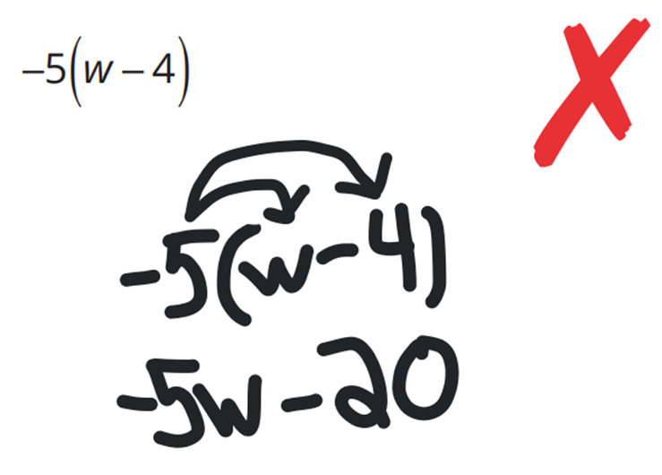  Destiny’s work: | What did Destiny do wrong when applying the distributive property?  She didn’t multiply …… and …… correctly.  What should the correct answer be?  $-5w+20$  Expand the following: $-2(w-7)$  $-2w+14$
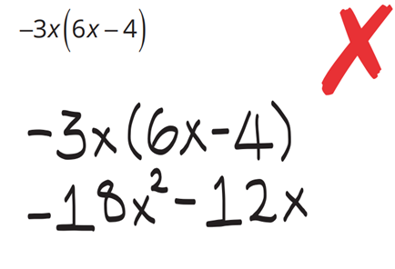  Hugo’s work | The correct answer is $-18x^{2}+12x$.  What rule did Hugo forget?  Negative times negative is ……………  Expand:  $$-3x(6x^{2}-4x)$$  $-18x^{3}+12x^{2}$
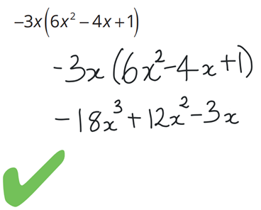  Alicia’s work | Why did Alicia write $-18x^{3}$ instead of $-18x^{2}$?  When you multiply $x$ and $x^{2}$, you add the ……………, so the answer is $x^{3}$  Expand:  $$-3x\left(6-4x+x^{2}\right)$$  $-18x+12x^{2}-3x^{3}$
Mora’s work  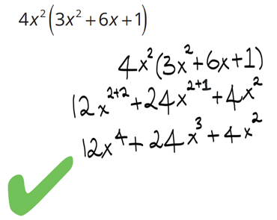 | Why did Mora add the exponents instead of multiplying them?  You add the exponents when ……………… terms with the same base.  Expand:  $$-4x^{2}\left(3x^{2}+6x+1\right)$$  $-12x^{4}-24x^{3}-4x^{2}$

Mastery
- Expand these expressions.
- $2(x+3)$  $2x-6$ | - $2(x-7)$  $2x-14$ | - $-\left(2+x\right)$  $-2-x$
- $4(7-x)$  $28-4x$ | - $6(2x+1)$  $12x+6$ | - $9(2w+3h)$  $18w+27h$
- $-3(x+2)$  $-3x-6$ | - $-5(x-3)$  $-5x+15$ | - $-4(2-x)$  $-8+4x$
- $-20(9+x)$  $-180-20x$ | - $-5(2w-3)$  $-10w+15$ | - $-(w+9)$  $-w-9$
- $4(m-3n+5)$  $4m-12n+20$ | - $-2(p-3q-2)$  $-2p+6q+4$ | - $2x(x+5)$  $2x^{2}+10x$
- $6a(a-4)$  $6a^{2}-24a$ | - $-4x(3x-4y)$  $-12x^{2}+16xy$ | - $3y(5y+z-8)$  $15y^{2}+3yz-24y$
- $-2a(4b-7a+10)$  $-8ab+14a^{2}-20a$ | - $7y(2y-2y^{2}-4)$  $14y^{2}-14y^{3}-28y$ | - $-3a(2a^{2}-a-1)$  $-6a^{3}+3a^{2}+4a$

- Decide what goes in the box to make the following true.
$$x$$ | $$x$$
$$5$$ | $$7$$
$$4$$ | $$4$$
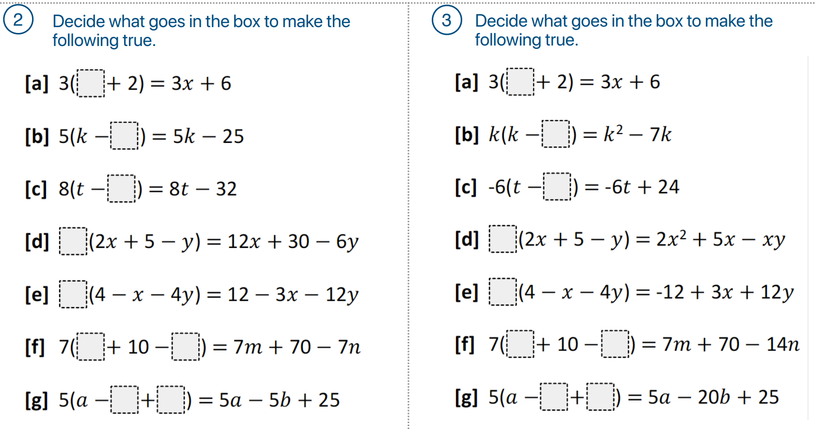  $$6$$ | $$x$$
$$3$$ | $$-3$$
$$m, n$$ | $$m, 2n$$
$$b, 5$$ | $$4b, 5$$

Expanding then Simplifying

- Review
- Simplify these expressions.
- $7a+8+12a$ | - $12x-8+9x-13$ | - $-5xy+55-7yx-3$
- $7a^{2}+3a-12a$ | - $9y-8x+12xy+9x$ | - $12xy^{2}-8y^{2}a+13$

- Expanding then Simplifying
After expanding brackets, simplify the result by combining like terms.

- Example Expand then simplify the result
$4\left(3p+2\right)-5p$  $=12p+8-5p$  $$=7p+8$$ | $5\left(2x-3\right)-4(1-5x)$  $=10x-15-4+20x$  $$=30x-19$$

- Guided Practice
Expand, then simplify.
- $5\left(3m+2\right)+4m$  $=$ $15m+10+4m$  $=$  $19m+10$ | - $3\left(1-5e\right)+6e$  $3-9e$
- $4w-2(5+2w)$  $=$ $4w-10-4w$  $=$  $-10$ | - $8-5(2x-7)$  $43-10x$
- $5\left(2a+3\right)+4(a+7)$  $14a+43$ | - $3\left(2d+3\right)-5(d+4)$  $d-11$

Foundation
- Expand the following and collect like terms.
- $3+2(x+4)$  $11+2x$ | - $2+5(3x-1)$  $-3+15x$ | - $3+4(x-2)$  $-5+4x$
- $3-4(x-2)$  $11-4x$ | - $1-5(x+4)$  $-19-5x$ | - $5-(x-6)$  $11-x$
- $9-(x-3)$  $12-x$ | - $5-(3+2x)$  $2-2x$ | - $7+2(x-3)$  $1+2x$

- Expand then simplify.
- $3\left(x-4\right)+1$  $$3x-11$$ | - $-3\left(x-4\right)+1$  $$-3x+13$$
- $3\left(x-4\right)-2$  $$3x-14$$ | - $-3\left(x-4\right)-2$  $$-3x+10$$
- $3\left(x-4\right)-x$  $$2x-12$$ | - $-3\left(x-4\right)-x$  $$-4x+12$$
- $3\left(x-4\right)-3x$  $$-12$$ | - $-3\left(x-4\right)-3x$  $$-6x+12$$
- $2+3\left(x-4\right)$  $$3x-10$$ | - $2-3\left(x-4\right)$  $$-3x+14$$
- $-3+3\left(x-4\right)$  $$3x-15$$ | - $-3-3\left(x-4\right)$  $$-3x+9$$
- $x+3\left(x-4\right)$  $$4x-12$$ | - $x-3\left(x-4\right)$  $$-2x+12$$
- $-2x+3\left(x-4\right)$  $$x-12$$ | - $-2x-3\left(x-4\right)$  $$-5x+12$$
- $3x\left(x-4\right)+2x$  $$3x^{2}-10x$$ | - $-3x\left(x-4\right)+2x$  $$-3x^{2}+14x$$
- $2x+3x\left(x-4\right)$  $$3x^{2}-10x$$ | - $2x-3x\left(x-4\right)$  $$-3x^{2}+14x$$
- $-2x+3x\left(x-4\right)$  $$3x^{2}-14x$$ | - $-2x-3x\left(x-4\right)$  $$-3x^{2}+10x$$

- Read the example carefully and answer the questions.
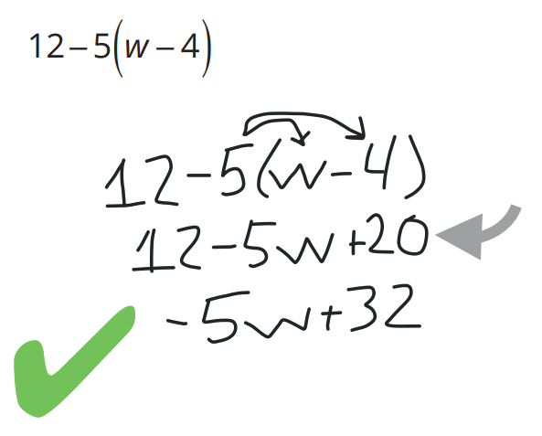  John’s work: | Where did the +20 come from in the step marked with an arrow?  …… $×$ …… $=20$  Would he have gotten the same answer if he first subtracted 5 from 12? Explain.  ………, you would get $7w$, which is incorrect as it doesn’t follow the ………… of ……………  Expand and simplify  $$12+5(w-4)$$  $5w-8$
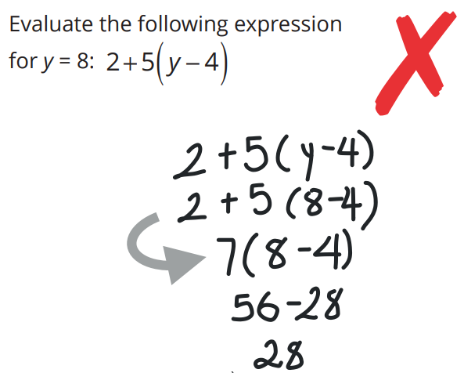  Louis’ work | What did Louis do in the step marked with an arrow?  Added ……… and ………  What should he have done instead?  …………… 4 from 8, or ………… the brackets.  Evaluate the following expression for $y = 8$:  $$2y+5(y-4)$$  $36$
Eric’s work  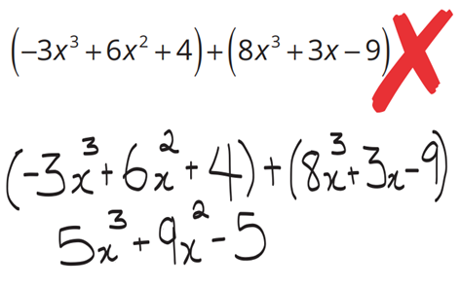 | Eric made a mistake when adding the terms. What did he add incorrectly?  He added ……… and …………, which are not ………… terms.  Simplify:  $$\left(-3x^{3}+6x^{2}+4x\right)+\left(8x^{3}-3x+9\right)$$  $5x^{3}+6x^{2}+x+9$

Development
- Expand and simplify.
- $3\left(x+2\right)+2\left(x+3\right)$  $$5x+12$$ | - $3\left(x+2\right)+2(x-3)$  $$5x$$
- $3\left(x+2\right)-2\left(x+3\right)$  $$x$$ | - $3\left(x+2\right)-2(x-3)$  $$x+12$$
- $p\left(p+2\right)+5\left(p+3\right)$  $$p^{2}+7p+15$$ | - $p\left(p-3\right)+p(p+3)$  $$2p^{2}$$
- $p\left(3-2p\right)-3p\left(p-2\right)$

$$-5p^{2}+9p$$

- Expand the following and collect like terms.
- $2(x+3)+3(x+2)$  $5x+12$ | - $3(2x+1)+5(x-1)$  $11x-2$ | - $4(3x+2)+5(x-3)$  $17x-7$
- $-2(x+2)+3(x-1)$  $x-7$ | - $2(4x-3)-2(3x-1)$  $2x-4$ | - $-(x+3)-3(x+5)$  $-4x-18$
- $-2(2x-4)-3(3x+5)$  $-13x-7$ | - $3(3x-1)-2(2-x)$  $11x-7$ | - −$4(5-x)-(2x-5)$  $2x-15$

- Expand and simplify these expressions.
- $2x\left(x+1\right)+3x\left(x+4\right)$  $$5x^{2}+14x$$ | - $3x\left(x+1\right)-5\left(x+4\right)$  $$3x^{2}-2x-20$$
- $3x\left(x+4\right)+2x\left(x+1\right)$  $$5x^{2}+14x$$ | - $3x^{2}\left(x+1\right)-5x\left(x+4\right)$  $$3x^{3}-2x^{2}-20x$$
- $3x\left(x+1\right)+2x\left(x+4\right)$  $$5x^{2}+11x$$ | - $3x^{2}\left(x-1\right)-5x\left(x-4\right)$  $$3x^{3}-8x^{2}+20x$$
- $3x\left(x-1\right)+2x\left(x+4\right)$  $$5x^{2}+5x$$ | - $3x^{2}\left(x-1\right)-\left(5x^{2}-4\right)$  $$3x^{3}-8x^{2}+4$$
- $3x\left(x+1\right)+2x\left(x-4\right)$  $$5x^{2}-5x$$ | - $3x^{2}\left(x-1\right)-5x^{2}$  $$3x^{3}-8x^{2}$$
- $3x\left(x-1\right)+2x\left(x-4\right)$  $$5x^{2}-11x$$ | - $5x^{2}-3x^{2}\left(x-1\right)$  $$8x^{2}-3x^{3}$$
- $3x\left(x-1\right)-2x\left(x-4\right)$  $$x^{2}+5x$$ | - $5-3x^{2}\left(x-1\right)$  $$5-3x^{3}+3x^{2}$$
- $3x\left(x+1\right)-2x\left(x+4\right)$  $$x^{2}-5x$$ | - $5+3x^{2}\left(1-x\right)$  $$5+3x^{2}-3x^{3}$$
- $3x\left(x+1\right)-2(x+4)$  $$3x^{2}+x-8$$ | - $5+3x^{2}(y-x)$  $$5+3x^{2}y-3x^{3}$$

Mastery
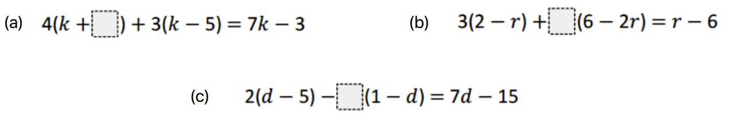
- Find the missing number to make these equations true.

3

$-2$

5
- Expand and simplify these expressions.
- $4x\left(3x+y\right)+2x(5x-2y)$  $22x^{2}$ | - $5m(4m-3n)-2m(9m-2n)$  $2m^{2}-11mn$
- $3a^{2}\left(4a^{3}-b^{4}\right)+2a^{2}(5a^{3}+3b^{4})$  $22a^{5}+3a^{2}b^{4}$ | - $2y^{3}\left(5y^{2}+3y^{4}\right)-4y^{2}\left(2y^{2}-y^{4}\right)$  $10y^{5}+6y^{7}-8y^{4}+4y^{6}$
- $5a^{2}b\left(2a^{3}b^{2}-3ab^{3}\right)-4a^{2}b\left(3a^{3}b^{2}-4ab^{3}\right)$

$$-2a^{5}b^{3}+a^{3}b^{4}$$

- Find the missing expressions to make these equations true.
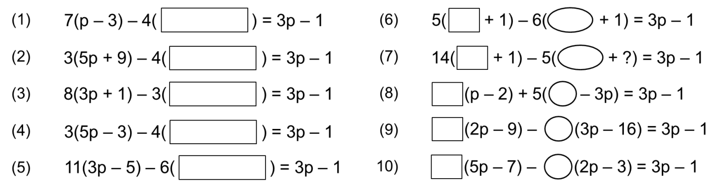

$$p-5$$

$3p+7$

$7p+3$

$3p-2$

$5p-9$

- Identify the mistake in these expansions, then write out the correct expansion.
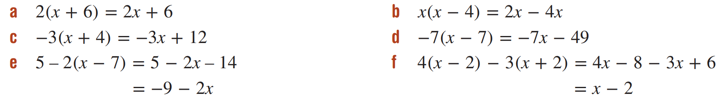  Mistake:  Didn’t multiply 2 and 6  Correct answer:  $2x+12$ | Mistake:  $x×x=x^{2}$  Correct answer:  $x^{2}-4x$
Mistake:  $-3×-4=12$  Correct answer:  $-3x-12$ | Mistake:  $-7×-7=+49$  Correct answer:  $-7x+49$
Mistake:  $-2×-7=+14$  Correct answer:  $19-2x$ | Mistake:  $-3×2=-6$  Correct answer:  $x-14$

- $5\left(2x+1\right)+c\left(x+d\right)=12x-1$
What is the value of $c$ and $d$?

$c=2, d=-3$

- Find the area of these basic shapes in expanded form.
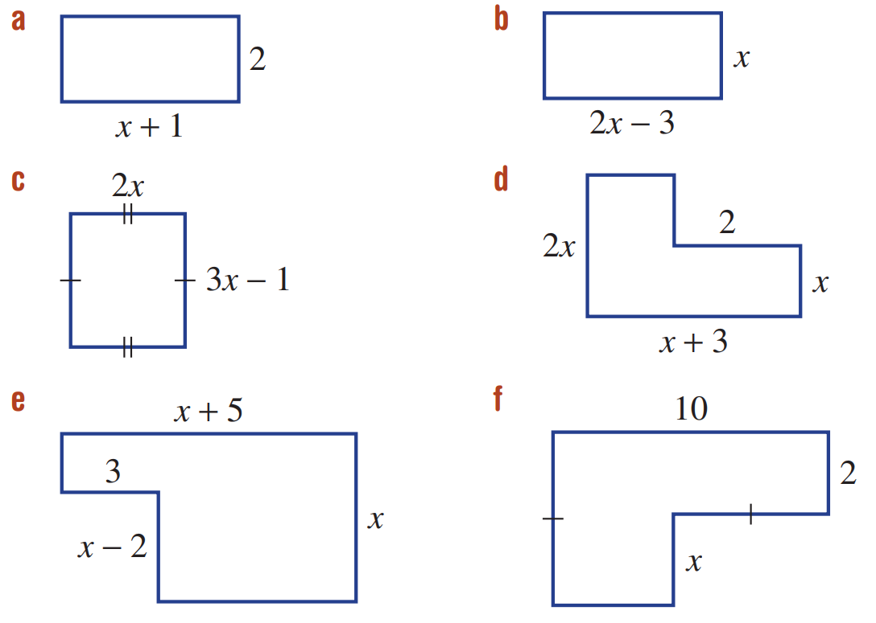  $2x+2$ | $2x^{2}-3x$ | $6x^{2}-2x$
$2x^{2}+4x$ | $6+x^{2}+2x$ | $20+8x-x^{2}$

Expanding Binomial Products

- Area Model
Calculate the following using the area model. (do not use the algorithm!)
- $6×58=6\left(50+8\right)$  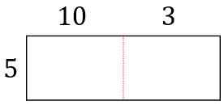  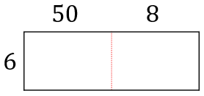 | - $5×13=5\left(10+3\right)$
- $23×56=\left(20+3\right)\left(50+6\right)$  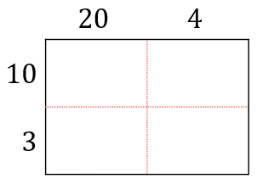  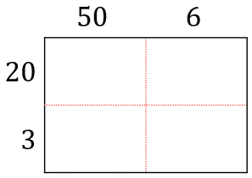 | - $13×24=\left(10+3\right)\left(20+4\right)$
- $a\left(c+d\right)$ | - $\left(a+b\right)\left(c+d\right)$  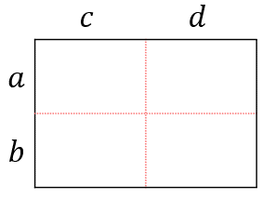  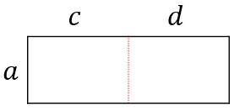

- Binomial Products
A binomial has two terms in its simplest form: $a+b$
When you multiply two binomial expressions, this is called a binomial product.
We can expand binomial products using the area model.
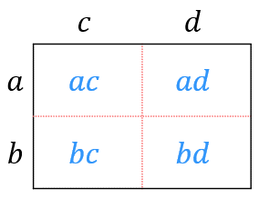
$$=\left(a+b\right)\left(c+d\right)$$
$=a\left(c+d\right)+b(c+d)$ $=ac+ad+bc+bd$

- Guided Practice
- $(p+4)(q+6)$  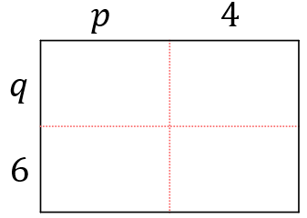  $=$ $p\left(q+6\right)+4(q+6)$  $=$ ………………………  $pq+4q+6p+24$ | - $(x-2)(x+6)$  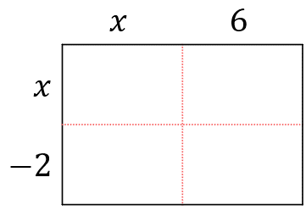  $=$ $x\left( \right)-2\left( \right)$  $=$  $=$  $x^{2}+4x-12$
- $(2a-b)(3a+2)$  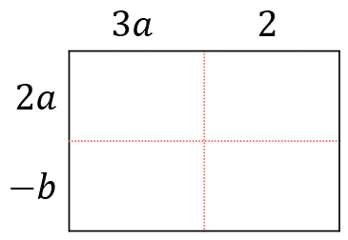  $6a^{2}+4a-3ab-2b$ | - $(4x+3)(2x+5)$  $8x^{2}+26x+15$

Foundation
- Expand these expressions. Use the area model to help you.
- $\left(a+3\right)\left(b+4\right)$  $ab+4a+3b+12$ | - $\left(a+2\right)\left(b+3\right)$  $ab+3a+2b+6$ | - $\left(x+2\right)\left(x+3\right)$  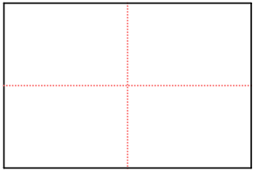  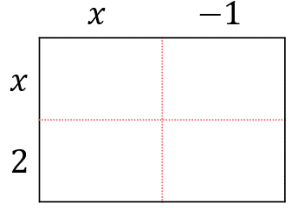  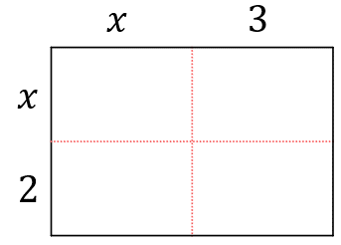  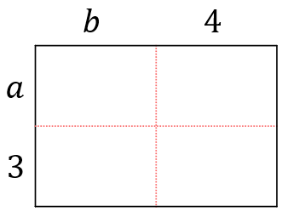  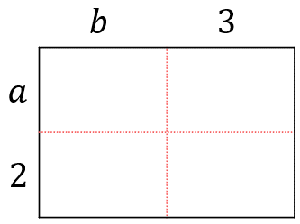  $x^{2}+5x+6$
- $\left(x+2\right)\left(x-1\right)$  $x^{2}+x-2$ | - $\left(2x+3\right)\left(x+1\right)$  $2x^{2}+5x+3$ | - $\left(x-2\right)\left(2x+5\right)$  $2x^{2}+x-10$

- Expand these expressions without an area model.
- $\left(x+1\right)\left(x+5\right)$  $=x\left(x+5\right)+1\left(x+5\right)$  $=$ …………………………  $=$ …………………………  $$x^{2}+6x+5$$ | - $(x-3)(x+2)$  $=$ $x\left( \right)-3\left( \right)$  $=$ …………………………  $=$ …………………………  $$x^{2}-x-6$$ | - $(3x-2)(7x+2)$  $=$ $3x\left( \right)-2\left( \right)$  $=$ …………………………  $=$ …………………………  $$21x^{2}-8x-4$$

- Expand these expressions. Set up an area model.
- $\left(x+y+5\right)\left(x+3\right)$  $$x^{2}+xy+8x+3y+15$$ | - $\left(x^{2}+2x+3\right)\left(x-5\right)$  $x^{3}-3x^{2}-7x-15$

Expanding Binomial Products using the Rule

- Expand Binomial Products using the Rule
- Multiply each term in the first bracket by each term in the second bracket.
- Simplify the result.

$$=\left(a+b\right)\left(c+d\right)$$  $=a\left(c+d\right)+b(c+d)$ $=ac+ad+bc+bd$ | 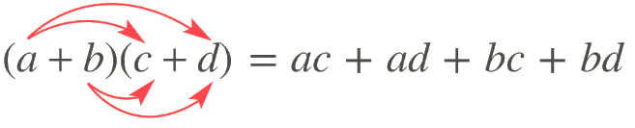  Shortcut:

- Example Expand binomial products
$(x+3)(x+5)$  $\left(x+3\right)\left(x+5\right)=x^{2}+5x+3x+15$  $=x^{2}+8x+15$ | $(x-4)(x+7)$  $\left(x-4\right)\left(x+7\right)=x^{2}+7x-4x-28$  $=x^{2}+3x-28$

- Guided Practice

Expand and simplify these expressions.
- $(x+4)(x+2)$  $$x^{2}+6x+8$$ | - $(x-5)(x-2)$  $$x^{2}-7x+10$$
- $(2x-1)(x-6)$  $$2x^{2}-13x+6$$ | - $(5x-2)(3x+7)$  $$15x^{2}+29x-14$$

- Key Ideas
- We can multiply binomials using the rule:
$\left(a+b\right)\left(x+y\right)=$ $a\left( \right)+b\left( \right)$
$=$ ………………………………………

Foundation
- Expand and simplify these expressions.
- $\left(x+5\right)\left(x+3\right)$  $x^{2}+8x+15$ | - $\left(x+6\right)\left(x-6\right)$  $x^{2}-36$
- $\left(x+3\right)\left(x+5\right)$  $x^{2}+8x+15$ | - $\left(x+5\right)\left(x-5\right)$  $x^{2}-25$
- $\left(x-3\right)\left(x+5\right)$  $x^{2}-2x-15$ | - $\left(x+5\right)\left(5-x\right)$  $-x^{2}+25$
- $\left(x+3\right)\left(x-5\right)$  $x^{2}-2x-15$ | - $\left(3x-1\right)\left(4x+4\right)$  $12x^{2}+8x-4$
- $\left(x-3\right)\left(x-5\right)$  $x^{2}-8x+15$ | - $\left(3x-1\right)\left(4x-4\right)$  $12x^{2}-16x+4$
- $\left(x-3\right)\left(x-3\right)$  $x^{2}-6x+9$ | - $\left(3x+2\right)\left(3x-2\right)$  $9x^{2}-4$
- ${(x-3)}^{2}$  $x^{2}-6x+9$ | - $\left(3x-2\right)\left(3x-2\right)$  $9x^{2}-12x+4$
- ${(x+3)}^{2}$  $x^{2}+6x+9$ | - $\left(ax-b\right)\left(cx-d\right)$  $acx^{2}-adx-bcx+bd$
- ${(x+6)}^{2}$  $x^{2}+12x+36$ | - $\left(ax+b\right)\left(cx+d\right)$  $acx^{2}+adx+bcx+bd$

- Read the example carefully and answer the questions.
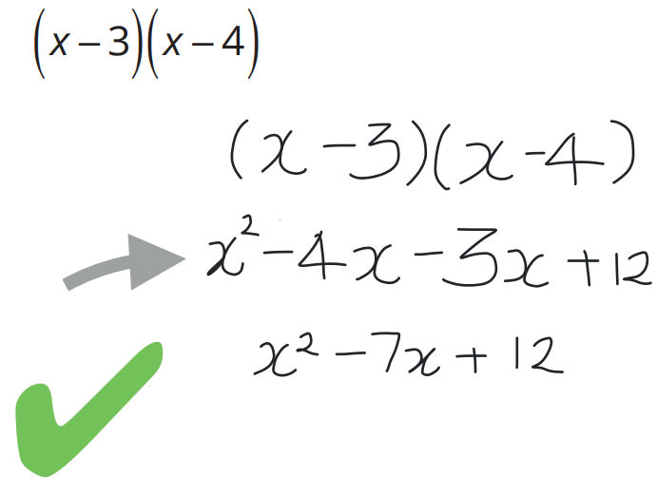 | In the step marked with an arrow, where did the + sign come from?  ……… $×$ ……… $=+12$  Expand  $$\left(x-3\right)\left(x-6\right)$$  $x^{2}-9x+18$
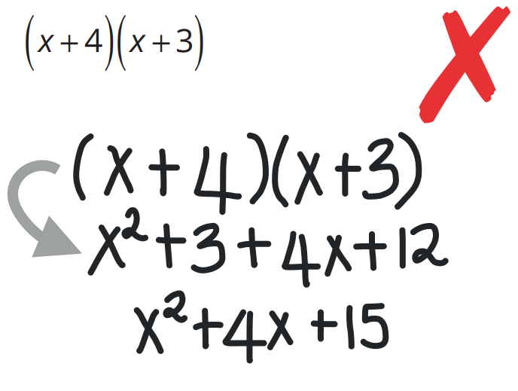 | In the step marked with an arrow, what mistake did this student make?  The 3 should be ……… instead.  Expand  $$\left(x+4\right)\left(x-3\right)$$  $$x^{2}+x-12$$
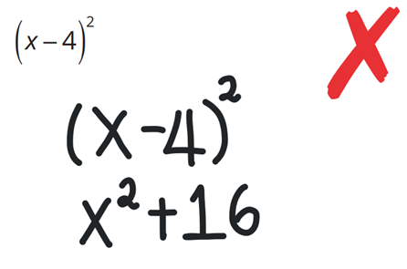 | What is another way that to write ${\left(x-4\right)}^{2}$?  ${\left(x-4\right)}^{2}=( )( )$  Expand  $${\left(x-4\right)}^{2}$$  $x^{2}+8x+16$

- Solve $2x+8=10$  $x=1$ | - Factorise $2x+8$  $2\left(x+4\right)$
- Evaluate $2x+8$ if $x=3$  $14$ | - Expand and simplify ${\left(2x+8\right)}^{2}$  $4x^{2}+32x+64$

